When working from home adopt the 6 R’s
Reduce, Reuse, Recycle, Repurpose, Refuse & Rejuvenate
You have been working from home for a while. Are you suffering from Zoom fatigue? Let’s learn how to practice the 6 R’s to help you sustain yourself and the environment while working from home. We will take one R at a time. You will learn how you can relax, stretch and recharge yourself while on Zoom. You can make simple changes to your surroundings at home to have a more inviting and sustainable environment. Do you take breaks while sitting? We will finish with a few chair stretches you can do. Just taking a few minutes to do stretches at your desk can relieve stress, increase productive and most importantly make you feel better. Cahir yoga participants can also enjoy other health benefits including improved muscle tone, better breathing habits, stress reduction, better sleep and an improved sense of well-being.
Reduce
Use less electricity by having your office by a window and use natural light
Get LED light bulbs
Turn off power or unplug when not using
Dress in layers turn down your heater
Make one trip and stop at all the locations making a list before you shop so that you are efficient in running your errands
Stay away from single use purchases and buy in bulk and use a bowl for your snacks
When you go outside for your walk and to get fresh air take a bag to pick up garbage along your route
Reuse
Use water bottles instead of bottled water
Use mug for coffee or tea
Use reusable bags
Practice minimization Beach towels/Pool towels/Bath towels
Use rechargeable batteries
Get an eco-friendly straw
Recycle
Gather the hard to recycle items and find a collection site near you
Save your glass and find a glass collection area near you
Buy Nothing Sell Nothing – Facebook Group for your area
Shop the Grove for cleaning products grove.co/home
Repurpose
Create a theme for you’re at home work place and use some forgotten items to change up your space. We have been working from home for a while. Do you need to change up your surroundings?
Add plants to your location
Wear second hand clothes to your Zoom meetings
Compost your food waste
Get that comfy chair
Free yourself of stuff so you will have more time to focus on what you truly care about.
Refuse
Zoom only schedules meetings on the half hour – block time for a break from Zoom for yourself
Adopt small rituals
Set parameters
Unsubscribe from unwanted email lists
Reply STOP to unwanted texts
Stop being a water waster – make sure you don’t have any drips, install new water saving fixtures, time your showers, turn off the water when brushing your teeth, use the water from your dehumidifier to water plants or for your laundry – cultivate good water habits
Run full loads for your dishwasher and washing machine
You can request no utensils with your to go or pick up orders and there are dining locations that you need to ask for utensils and napkins to keep waste to a minimum. Refuse the straw use a disposable one.

One take-out restaurant that mostly avoids single use plastics is Chipotle. They food tray is paper and the top is aluminum. Find more green restaurants here. https://sustainablepghrestaurants.org/site/restaurant-finder/

Don’t print – scan, screen shot, copy to chat or screen share, etc. End the paper clutter!
REWARD yourself with something small to look forward to
Manage distractions by putting up a sign or close the door so you can focus and pay attention
Get up earlier and do your harder tasks while it’s quiet and you have a fresh start to your day
When you will be distracted do your low attention tasks or take shifts with another adult so your distraction is minimized when you need to focus
Rejuvenate
Look out 2021 – Here I come! I am taking care of number one. ME!
Goals:
Exercise 4 times a week for 20 minutes to develop a habit
Drink more water
Eat more fresh fruits & vegetables
Practice balance daily
Have a meditation/gratitude session
One line a day journal – write a positive comment
Get more sleep
Choose kind and happy
Give yourself grace and patience
Make healthy choices?
Focus on what you can do and control
Avoid Zoom fatigue. Don’t be sedentary try some chair stretches or chair yoga poses to move around between your calls

Things that may surprise you:
- Do not bag your curbside items. Place them directly into a blue recycling bin.
- Glass may not be recyclable in your area anymore. Check with your local municipality.
- No pizza boxes if they are soiled. If the top is not soiled, you can cut the top off of it and recycle it separately from the soiled portion.
Glass:
There are permanent drop-off locations and many temporary drop-offs. The city has roll offs for glass at Construction Junction and the 31st Street City site in the Strip District. Click on this link for more information
https://pittsburghpa.gov/dpw/drop-off
- Beltzhoover/Knoxville 24 hour drop off
623 Bausman St Pittsburgh, PA 15210
412-225-2631
- Strip District 24 hour drop off
3001 Railroad St Pittsburgh, PA 15201
412-255-2631
- Construction Junction 9am-5pm Monday – Saturday; Sunday Noon-3
214 North Lexington St Pittsburgh, PA 15208
412-243-5025
To find other locations outside the City of Pittsburgh and/or temporary drop-offs, click here or see link below.
https://prc.org/programs/collection-events/glassrecycling/
Pennsylvania Resources Council’s website is a valuable resource on how to find other drop off locations for other kinds of recyclables (i.e. chemicals, prescriptions, etc.). Click here or see link below for more info.
https://prc.org/programs/collection-events/
Household Hazardous Waste (HHW)
Household Hazardous Waste is typically comprised of unused household products that may explode, catch fire or be generally harmful to the environment if not properly disposed. Follow the link below for more information.
https://www.dep.pa.gov/Citizens/RecyclingDisposal/HouseholdHazardousWaste/Pages/default.aspx
Don’t know what an HHW is? Review this document by following the link below
http://files.dep.state.pa.us/Waste/Bureau%20of%20Waste%20Management/lib/landrecwaste/hhw/hhw.pdf
Household Hazardous Waste Collection Programs information is found by following this link
https://www.dep.pa.gov/Business/Land/Waste/SolidWaste/HazardousWaste/Household/Pages/HHW-Collection-Programs.aspx
Curbside HHW Collection Programs can be found by following this link
https://www.dep.pa.gov/Business/Land/Waste/Recycling/Electronics/Pages/Special-Waste-Materials-Curbside-Collection-Programs.aspx
Other items:
Not sure how to recycle books, paper, electronics or other items? Checkout the Allegheny County Recycling Resource Directory by clicking here or see the link below.
https://www.alleghenycounty.us/uploadedFiles/Allegheny_Home/Health_Department/Programs/Waste-_and_Water-Related/Recycling/Recycling_Resource_Directory.pdf
Need more help?
- Your County Recycling Coordinator is the number one resource for details on your county’s drop-off locations, municipal recycling programs, special collection events and programs, and other useful local recycling information.

Allegheny County Recycling Coordinator
Joy Smallwood
412-578-8390 or Joy.Smallwood@AlleghenyCounty.US
Pennsylvania residents outside of Allegheny County? Click here or see link below to find your recycling coordinator.
https://www.dep.pa.gov/Business/Land/Waste/Recycling/PublicResources/Pages/County-Recycling-Coordinators.aspx
- Pennsylvania DEP’s Recycling Hotline
800-346-4242
At home recycling & hazardous waste resources
The City has roll offs for glass at Construction Conjunction and at the 31st Street City site.

https://prc.org/programs/collection-events/glassrecycling/

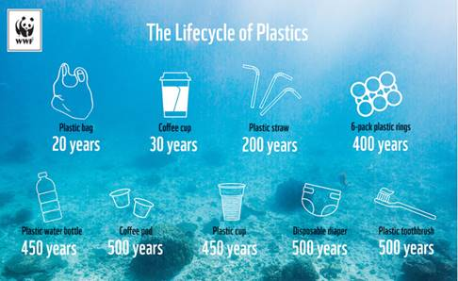
Deeper Dive The Ultimate Guide to Working from Home: 26 Tips for Maximum Productivity Here is a helpful guide to help you stay focused and productive working from home.
• Dean Bokhari Working from Home
https://www.deanbokhari.com/working-from-home/

The People’s Ecochallenge 2020 Actions The People's EcoChallenge is our global community's most popular EcoChallenge, offering a vast library of actions. Check out the 200+ actions that you can practice anytime.
• People’s EcoChallenge
https://peoples.ecochallenge.org/

Compiled by the CMU Green Practices Committee October 30, 2020
• Environment at CMU Website
https://www.cmu.edu/environment/

Chair yoga video and poses
https://www.verywellfit.com/chair-yoga-poses-3567189?utm_campaign=fitsl&utm_medium=email&utm_source=cn_nl&utm_content=19858007&utm_term=

- 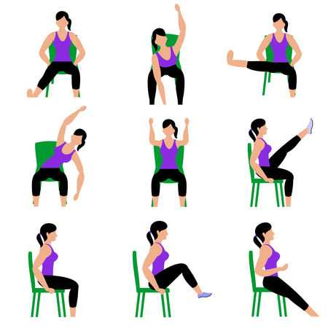
- Chair Exercises | - Stretches
- Head | - Head forward and back/side to side
- Shoulders | - Shoulders up and down
- Arms | - Arm circle
- Waist | - Waist bend side to side
- Twist | - Twist rotate side to side
- Reach | - Reach overhead
- Forward Lean | - Forward Bend
- Side Bend | - Side Bend and reach
- Figure 4 | - Figure 4 lean forward
- Knees | - Knee Squeeze
- Knee Lift | - Lift both knees up
- Legs | - Both legs straight and lean forward
- Leg lift | - Lift both legs straight
- Wrists | - Move up and down, side to side, supinate & pronate

